Black Population Chart
Years | Black Population Numbers | Enslaved Black Population Numbers | Free Black Population Numbers | Philadelphia’s Total Population | Percentages of the Black Population within Philadelphia’s Total Population
Today

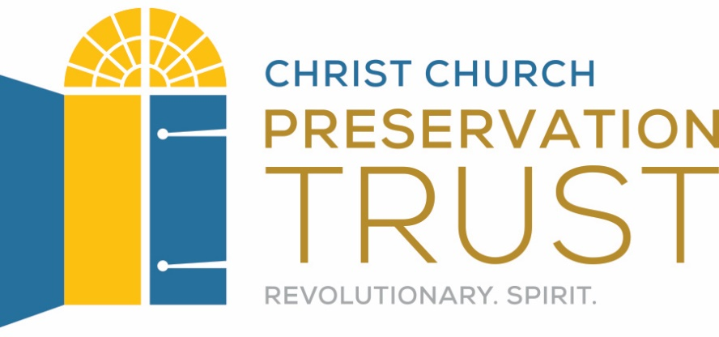
These plans were developed by Chen Chang as a Drexel University Capstone MLIS project in conjunction with Christ Church Preservation Trust and the CLIR funded Digitizing Philadelphia’s Historic Congregations project: www.philadelphiacongregations.org.

