Primary Sources Questions
Who? Whom? What? Where? When? Why? How?
- Who created this document? What do you know about the author? Does knowing about the author matter in studying the document? If so, how does it help or hinder you?

- Whom was this document created for? In other words, who was the target audience? Was it for private or public use?

- What is this document? Look at it and describe any physical traits you notice. (For example: Was it a letter written on scrap paper with messy writing, or was it a list of expenses written in a book with pencil?) What can these traits tell you about this document? Can you find any inconsistencies or uncertainties?

- Where was this document created? Does place matter in studying the document? If so, what is the significance of the document in terms of its place of creation?

- When was this document created? What does it reveal about the time period it was created in? Are there any significant events happening during this time?

- Why was this document created? Is its purpose to inform or persuade? Why does this document matter? What is the historical significance of this document?

- How can you use this document to study the past? What questions can it answer? What questions can it NOT answer?

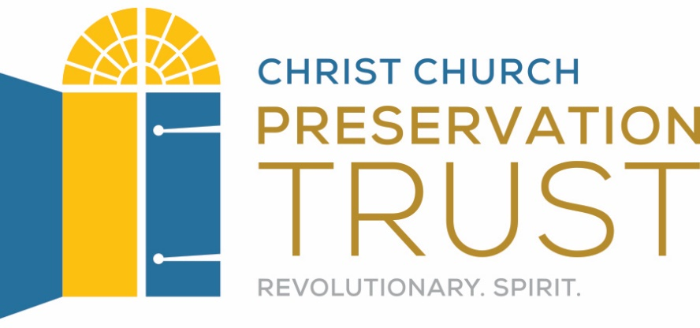
These plans were developed by Chen Chang as a Drexel University Capstone MLIS project in conjunction with Christ Church Preservation Trust and the CLIR funded Digitizing Philadelphia’s Historic Congregations project: www.philadelphiacongregations.org.

